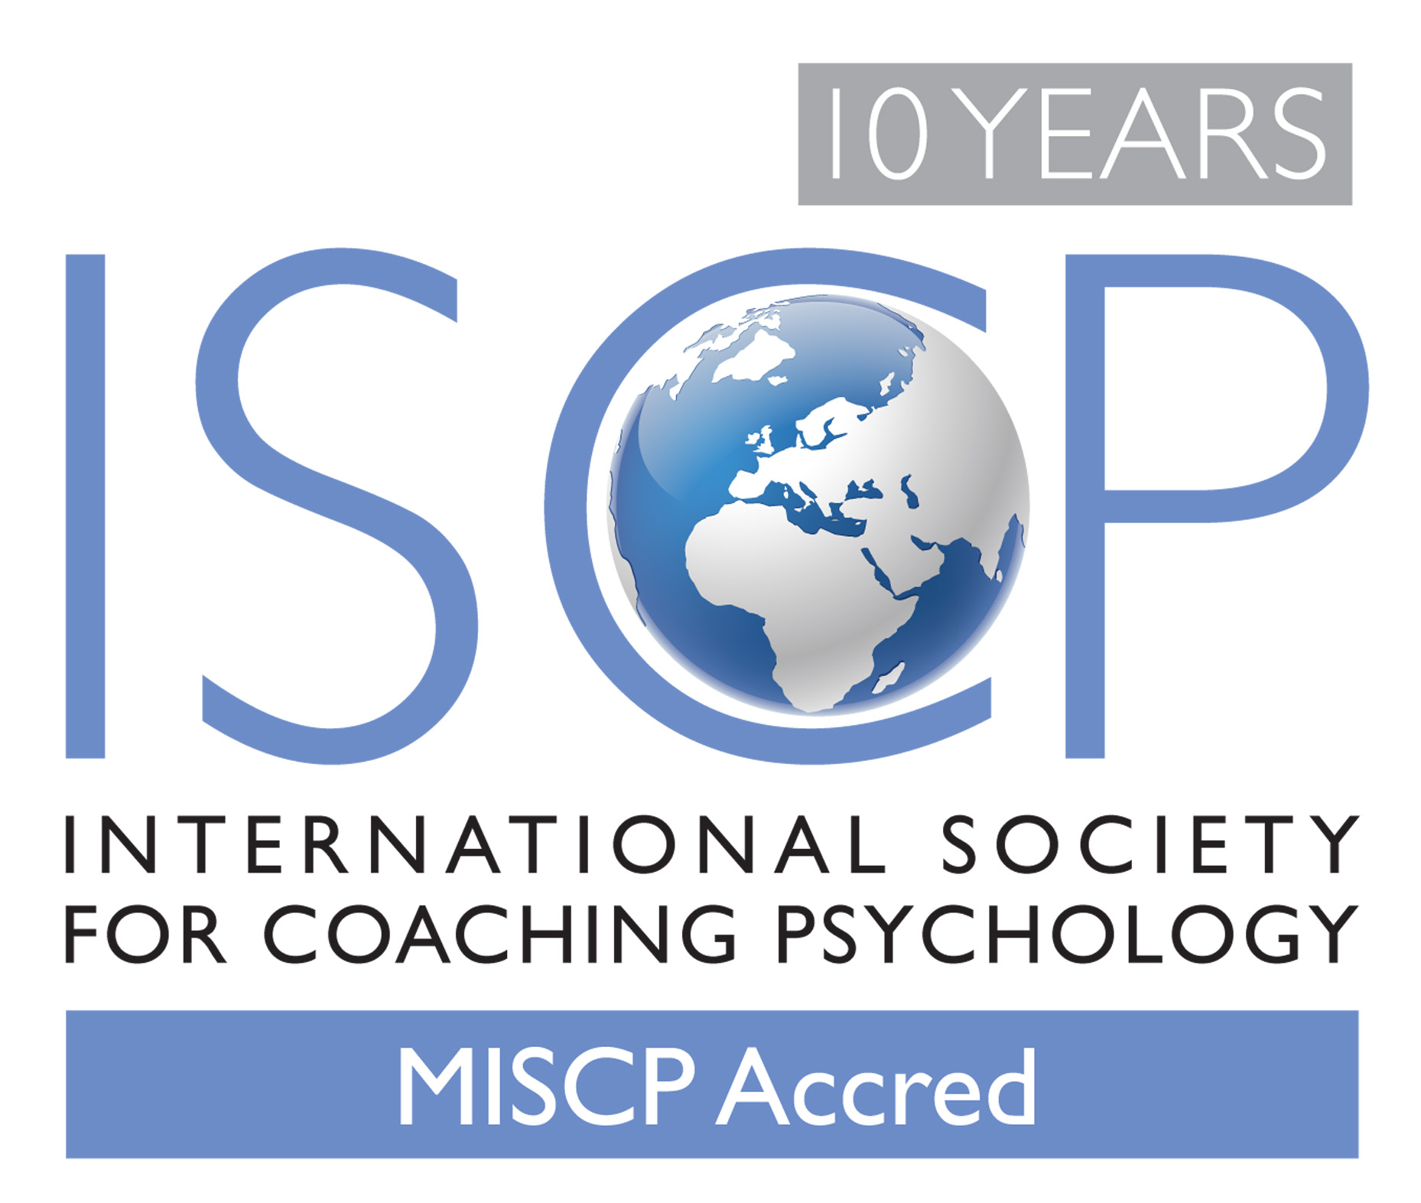

International Society for Coaching Psychology

Accreditation/Certification Process

Name of Applicant*: …………………………………………………………….

* Please insert your name here

Table of Contents
Section |  | Page
I | Introduction | 1
II | Mandatory Requirements | 1
III | Assessment of Applications | 2
IV | Portfolio System of Accreditation/Certification  for AssocMISCP’s | 3
V | Additional Information | 3
VI | Information for Applicants & Form | 4
Figure 1 | Areas for ISCP Accreditation/Certification Assessment | 2
Appendix I | Description of Key Terms
Appendix II | CPD/CPE LOG for MISCP
Appendix III | Applicants Reflection Sheet on Supervision Process
Appendix IV | Applicants Reflection on Coaching Psychology Practice
Appendix V | Supervisors Reference Form for MISCP Accred Application

I. Introduction
Stage one of the International Society for Coaching Psychology (ISCP) accreditation/certification process is offered to existing qualified psychologists who are members of ISCP. This is a grandparenting process.
Accredited Members of the ISCP are persons who hold a recognised degree in psychology and a coaching psychology qualification and/or by virtue of their recognised degree in psychology, experience and continuing professional development, satisfy the Council and its representative Accreditation/Certification Board, that they possess an understanding of the principles of evidence-based coaching psychology and are competent to undertake its practice.

II. Mandatory Requirements
The following sets out the mandatory requirements of the accreditation/certification grandparenting system for qualified psychologists who are also coaching psychologists.
- Evidence of qualified psychologist status.
- Evidence of two years practice as a Coaching Psychologist post qualification (see point 1 above).
- Evidence of supervision from a qualified psychologist.
- Evidence of Professional Indemnity Insurance. Please note the limit of indemnity should be a minimum of £1 million (GBP) or equivalent.
- Evidence of activities undertaken to demonstrate annual continued professional development (CPD) or education (CPE) covering the last two-year period with a minimum of 40 hours for each year. Further guidance is available in Appendix II.
- Reflective summary of applicant experiences as a Supervisee (to cover the assessment period set out in the application)
- Illustrative example from applicants coaching psychology practice
Examples of evidence that may be presented to demonstrate CPD/CPE are available in Table 1 (Appendix II). To remain on the Society’s register of accredited/certified coaching psychologists, members must submit an annual CPD/CPE Log to the society’s Membership Secretary on request. This is available in Table 3 (Appendix II). The Supervisors reference form for MISCP Accred membership status is provided in Appendix III.

In many cases, evidence relating to points 1 and 2 above will be provided when members submit an application to join the Society. If you are already a member of the Society when you complete two years post-qualified practice you should contact the Honorary Membership Secretary via e-mail for guidance on completing the accreditation application process (membership@isfcp.net).
III. Assessment of Applications
Submissions will be viewed by the ISCP Accreditation/Certification Board and a response will be provided within 8 weeks from the receipt of your application.
Key areas that the Accreditation/Certification Assessors will be considering in relation to evidence of coaching psychology practice, supervision and CPD/CPE activities are outlined in Figure 1.

EVIDENCE-BASED COACHING PSYCHOLOGY
PRACTICE

- Rights & Respect
- Recognition
- Relationship
- Representation
- Responsibility

RESEARCH

THEORY & SCIENTIFIC KNOWLEDGE
ETHICS
- Rights
- Respect
- Recognition
- Relationship
- Representation
- Responsibility
Figure 1. Key areas for ISCP Accreditation/Certification Assessment
Figure 1 should not be reproduced except with written permission of the Society for Coaching Psychology

Note that the Society’s Codes of Ethics and Guide to Coaching Psychology Practice inform key areas in Figure 1, which can be downloaded from our website.

IV. Portfolio System of Accreditation/Certification for AssocMISCP’s
During 2008-9 the ISCP developed a portfolio system of accreditation/certification for AssocMSCP’s. This enables graduate members of the ISCP to progress to a full Member of the Society (MISCP) by building up a portfolio of coaching psychology learning and competencies. They will then be able to work towards MISCP Accred membership status.
AssocMISCP’s will be required to provide evidence of activities undertaken to demonstrate a total of 120 hours (40 hours per annum) of annual Initial Professional Development (IPD) during a three year period to achieve MISCP status.
The activities undertaken to provide evidence of IPD differ from the CPD/CPE activities set out in Table 1 (Appendix II) and include additional self-learning activities such as reading coaching psychology books.
During 2008-9 the ISCP introduced a system of course recognition to provide members with details of courses recognized by the Society as offering coaching psychology CPD/CPE and IPD. As the first stage of this work focused on CPD/CPE, AssocMISCP’s will be able to use these ISCP CPD/CPE recognised courses towards their Associate Member IPD logbook.
Associate members will be able to include evidence of 100 hours of IPD as evidence in their IPD logbook when undertaken in the two and a half years prior to joining the Society. However, the remaining 20 hours to demonstrate required IPD learning and competencies must be undertaken over a six month period as a AssocMISCP.
V. Additional Information:
The accreditation/certification process will be undertaken in stages as the ISCP focuses on psychology qualifications from around the world. If necessary, a Regional certification system may be set up to reflect local needs.
The certification being developed by the Society may not be recognised by individual states or countries. However, most importantly, it will ensure that Society Accredited or Certified Coaching Psychologists have to maintain relevant annual CPD/CPE and obtain regular supervision or consultation for their work. This will benefit the practitioner, their coachees and client organisations.
VI. Information for Applicants & Form
Admission to the Society at this membership grade entitles a Member to use the post-nominal letters MISCP Accred and the associated ISCP logo. They can describe themselves as a Society for Coaching Psychology Accredited or Certified Coaching Psychologist or another designation approved by The Council.
1 PERSONAL DETAILS
TITLE (Ms/Miss/Mrs/Mr/Dr/Prof/Other)

FIRST/GIVEN NAME(S) | SURNAME/FAMILY NAME
CORRESPONDENCE ADDRESS (including UK postcode)

Main contact numbers:
Telephone
Mobile
Fax
Email

Website Address:

2 MANDATORY REQUIREMENTS
Are you currently a member of the International Society for Coaching Psychology?  If no, please visit the Application & Fees section of our website and submit a membership application and the required joining fees with this submission. This application form requires you to provide evidence of the following mandatory requirements to fulfill MISCP Accred membership status:  - Evidence of qualified psychologist status.  - Evidence of two years practice as a Coaching Psychologist post qualification. | YES NO
If you are currently listed as a qualified psychologist on the on-line directory of a nationally recognised professional psychology body you should provide the full website address here:

If you are listed on this on-line directory under an alternative home or business address to the correspondence address listed in box 1 provide this here:

If you are not listed on an on-line directory of a nationally recognized professional psychology body you should send hard copy evidence of your qualified psychologist status with this application.

Please note, the ISCP reserves the right to also request hard copy evidence of qualified psychologist status.

2 MANDATORY REQUIREMENTS Continued
Please provide the name and a valid e-mail address for your Supervisor below.

Your Supervisor should hold a nationally recognised qualification for your country
(eg Chartered Psychologist in the UK; Registered Psychologist in Australia; state licensed in USA):

Supervisors name and e- mail address: ……………………………………………………………………………………………………………………………

Please note:

- the Society’s preferred method of communication with referees is via e-mail
- this e-mail address will be used by the ISCP to request your Supervisors reference (See Appendix III for the Supervisors Reference Form for MISCPAccred Applications). Please do not submit the Supervisors reference as part of your application.
- If you provide an invalid e-mail address your application cannot be processed.

The ISCP reserves the right to undertake additional checks and enter into correspondences with referees to verify the information provided.

Have you enclosed the required evidence of current Professional Indemnity Insurance?  If you have answered no to this question, your application will be rejected. | YES NO
Have you provided evidence of activities undertaken to demonstrate continued professional development (CPD) or education (CPE) covering the last two-year period with a minimum of 40 hours for each of these years?  Further information is available in Appendix II.  Please note:  - A minimum of 40 hours CPD/E to have been undertaken in each year of which 30 hours is specifically related to coaching psychology and the remaining 10 hours is general psychology CPD/CPE. Further information is available in Table 1 (Appendix II).  - The combined total of the two years CPD/E should be a minimum of 80 hours.  - The SCP’s CPD/CPE Log is available in Table 3 (Appendix II)  If you have answered no to this question, your application will be rejected. The ISCP reserves the right to request hard copy evidence of CPD activities. | YES NO
Have you provided:  - Reflective summary of applicant experiences as a Supervisee (to cover the assessment period set out in the application) – Appendix III  - Illustrative example from applicants coaching psychology practice – Appendix IV | YES NO

3 Coaching Psychology Qualifications & Experience
Please list all relevant coaching psychology qualifications, which could include psychology related qualifications such as counseling, therapy and psychometric testing. Also provide details below of relevant experience (e.g. providing coaching psychology services, researching coaching psychology practice/theory, training others in coaching psychology/coaching, supervising others, receiving supervision, relevant publications).
NB: The ISCP reserves the right to request copies of the relevant qualifications listed in this application.
Nature of Qualification/Work  (Please ensure this section clearly specifies the nature and duration of your coaching psychology experience) | DATES  (month and year)  From To | INSTITUTION/EMPLOYER

Please note that if applications are discovered to contain any false entries, misleading statements or material omissions the International Society for Coaching Psychology reserve the right to cancel the application or later revoke your membership.

I certify that the information given on this form is correct and complete to the best of my knowledge. I give my consent for the information to be used for staff administration and research purposes, for Society for Coaching Psychology to contact third parties to verify the information, and for those third parties to release personal data about me in the verification process, in accordance with the Data Protection Act 1998.

By submitting this application form you are also confirming that:

- I agree to support the International Society for Coaching Psychology in achieving its aims and objectives.
- I agree to abide by the codes of ethics and practice of the Society.
- I am not aware of any outstanding complaints registered against me with another professional body.

APPLICANT’S SIGNATURE ................................................ DATE ........................

1. Fees

During the founding membership period the fee to apply for accredited member status was £75 (GBP).

Please note: the founding membership period ended on 31st December 2011 at which stage the fee to apply for accredited member status is £150 (GBP).

2. Send the completed application form, fee, evidence and copies of the required documentation to:

i) Electronic submissions of the application form and copies of supporting documentation to be e-mailed to membership@isfcp.net.

ii) We will contact you with payment information. Please note, your application will not be finalised until the correct payment has been received.

NB. Your application will not be processed unless the fee, a completed signed application form and all supporting evidence are submitted with your submission.

Appendix I Description of Key Terms

Qualified Psychologist: As an international professional body the Society acknowledges that pre-requisites for the status of qualified psychologist are based on regionally or nationally recognized qualifications. For example, nationally recognized qualifications currently include Chartered Psychologist in the UK, Registered Psychologist in Australia and state licensed in USA. By laying claim to this title you are required to submit evidence with your application that your qualifications are considered to currently meet the criteria of a qualified psychologist via the accepted level of membership of a national psychology body.
ISCP’s Grandparenting Process to Accreditation/Certification: This is a route by which individuals provide evidence of their existing status as a qualified psychologist and the mandatory requirements as set out above.

Appendix II
International Society for Coaching Psychology CPD/CPE Log for MISCP

Qualified Psychologists wishing to work towards the Society’s accreditation or certification process will need to provide evidence of annual continued professional development (CPD) or education (CPE) covering the last two-year period with a minimum of 40 hours for each of these years. Thus, the combined total of these two years CPD/E would be a minimum of 80 hours.
This will be mandatory in order to achieve and maintain ISCP accredited or certified coaching psychologist status. They will also need to have regular supervision/consultation of their coaching and coaching psychology practice from a qualified psychologist.
Of these 40 hours of annual psychology related annual CPD/CPE, a minimum of 30 hours should be undertaken specifically relating to coaching psychology. Please note, these activities should also reflect coaching psychology and not coaching.
Examples of appropriate CPD/CPE activities are set out in Table 1, which also represents the maximum contribution that each activity can make to the total hours of CPD/CPE evidence. Table 3 provides the annual CPD/CPE log which should be submitted to the ISCP with supporting evidence when applying for MISCP Accred status and afterward on request from the ISCP Membership Secretary.

Table 1 Example CPD/CPE Activities

Example of Activity | Total maximum contribution to 40 hours of CPD/CPE
Psychology related CPD/CPE | 10 Hours
Reading coaching psychology books/journals. | 15 Hours
Publishing articles in peer reviewed journals, chapters and/or books. Undertaking coaching psychology research. | 15 Hours
Attendance at coaching psychology or relevant workshops, seminars and conferences. | No maximum
Developing and delivering coaching psychology related workshops; giving conference papers or keynotes. | 15 Hours
Related developmental activities such as peer observation, chairing meetings or participation in professional coaching psychology activities. | 5 Hours

Additional notes for completion of the CPD/E Log provided in Table 3:
- Please ensure a separate log is submitted with your application for each of the two years required, noting that:
  - Evidence of activities undertaken to demonstrate continued professional development (CPD) or education (CPE) covering the last two-year period with a minimum of 40 hours for each of these years should be provided
  - A minimum of 40 hours CPD/E to have been undertaken in each year of which 30 hours is specifically related to coaching psychology and the remaining 10 hours is general psychology CPD/CPE. Further information is available in Table 1 (Appendix II).
  - The combined total of the two years CPD/E should be a minimum of 80 hours.
- Please list the Type of CPD/E Activity on your log in the order shown in Table 1
- Table 2 provides summary details of how to complete the annual CPD/E log.

Table 2 Summary Details for Completion of the CPD Log

Name: To be inserted here.
International Society for Coaching Psychology Membership Number: To be inserted here.
Date for CPD Log (e.g. Months & Year): To be inserted here for each year

Type of CPD Activity | Description of CPD Activity |  | Contribution in Hours to CPD
Psychology related CPD/CPE | This might include broader activities that are psychology related but are not specifically coaching psychology |  | A maximum of 10 hours to be included
Reading Coaching Psychology Books/Journals | Provide specific details relating to the author and title of the book, the number of hours spent reading and reflect upon your learning. |  | A maximum of 15 hours to be included
Publishing Articles in Peer Reviewed Journals & Books | Provide specific details relating to the title of the article, journal, chapter, book &/or about the research being undertaken. |  | A maximum of 15 hours to be included
Attendance at coaching psychology or relevant workshops, seminars and conferences. | Provide specific details relating to the title of the event, the date[s] you attended, the course/workshop/conference provider and the name of the trainers/facilitators. |  | No maximum
Developing and delivering coaching & coaching psychology related workshops; giving conference papers or keynotes. | Provide specific details relating to the title of the workshop, conference paper or keynote and the date[s] and event[s] delivered. |  | A maximum of 15 hours to be included
Related developmental activities such as peer observation, chairing meetings or participation in professional coaching psychology activities. | Provide dates and outline further relevant supporting information here. |  | A maximum of 5 hours to be included
NB: Please add additional rows if required. |  | Total Hours | A minimum of 40 Hours to have been undertaken for each year

Table 3 Evidence Log of CPD/CPE Activities

Name:
International Society for Coaching Psychology Membership Number:
Date for CPD Log (e.g. Months & Year):

Type of CPD Activity | Description of CPD Activity | Contribution in Hours to CPD

Continued on next page …
Name:

Type of CPD Activity | Description of CPD Activity | Contribution in Hours to CPD

NB: Please add additional rows if required. | Total Hours

Appendix III Applicant Reflections on Supervision Process

Applicants Reflections on the Supervision Process
Please provide summary reflections in the box below about your experiences of the Supervision process (as the supervisee) during the assessment period of this application. As a guide you might share an example of how supervision has benefitted you and the type and quantity of supervision received during this period (e.g. consultative, peer, one-to-one, group)

Appendix IV Applicant Reflections on Coaching Psychology Practice

Applicants Example to Reflect Coaching Psychology Practice
Please provide an illustrative example below that you feel represents your coaching psychology approach and comment upon how this relates to the key areas of ‘evidence based coaching psychology’ for ISCP Accreditation / Certification Assessment (as set out in Figure 1 above) and the six principles of the Society’s Code of Ethics.

You must anonymise any coachee/client/sponsor/stakeholder/third party information and seek consent from all parties involved prior to submission of your application.

Appendix V Supervisor Reference Form for MISCP Accred. Application

Supervisor’s Reference
for the International Society for Coaching Psychology
Your Full Name and Title:
Name of Applicant:
1. Are you a Qualified Psychologist?
(e.g. Chartered Psychologist in the UK; Registered Psychologist in Australia; state licensed in USA)
2. Over what period of time have you supervised the person named above? | Years |  | Months
3. Do you support this person's application to become an accredited/certified member of the Society for Coaching Psychology (SCP)?
4. On what basis do you support this person’s application to become an accredited/certified member of the SCP?
(NB: Please consider the key areas of ‘evidence based coaching psychology’ for ISCP Accreditation/Certification Assessment (as set out in Figure 1 of the International Society for Coaching Psychology Accreditation/Certification Process document, which can be downloaded from the Society’s website http://www.isfcp.net/accreditation.htm) As a guide This should include reference to their coaching psychology skills, experience, attitude to CPD and professional standards).
5. In what ways does this person apply the six principles as set out in the Society’s Code of Ethics? (Please see: http://www.isfcp.net/ethics.htm)
Supervisors Signature:
Date:

Guidelines for usage of the ISCP logo[s] are available on the Society’s website

