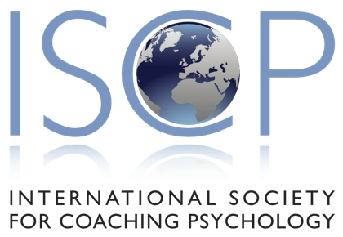

Application Form for Course or Workshop Recognition
by the International Society for Coaching Psychology

Following confirmation that your application has been successful your organisation will be entitled to state that the course or workshop is ‘Recognised by The International Society for Coaching Psychology as providing CPD/CPE for its Members’.

1 ORGANISATION DETAILS
NAME OF ORGANISATION

ADDRESS

Main contact numbers:  Telephone  Email | Website Address:
Website link to Course Brochure:
Alternatively a copy of the course brochure should be attached to your application.

2 COURSE DIRECTORS DETAILS
TITLE (Ms/Miss/Mrs/Mr/Dr/Prof/Other) | NAME(S)
IMPORTANT YES
Is the Course Director a full member of the International Society for Coaching with the member grade MISCP?
NB: If you have been unable to answer ‘yes’ to this question we will not be able to process your application. Please visit the ISCP website for membership and joining details http://www.isfcp.net

3 COURSE/WORKSHOP DETAILS
Please provide the following information relating to the course/workshop.
TRAINER[S]/TUTOR[S] DETAILS:
Please include the names of regular trainer[s] or tutor[s] and give brief professional background information. If trainers are members of the ISCP it will be sufficient to state their name and membership grade.
TITLE OF COURSE/WORKSHOP:

IF THE COURSE IS ACCREDITED &/OR RECOGNISED BY OTHER BODIES GIVE DETAILS HERE:
AIMS AND OBJECTIVES OF THE COURSE/WORKSHOP:
COURSE/WORKSHOP DATE[S]:
NUMBER OF CONTACT TRAINING HOURS:
NUMBER OF CPD/CPE HOURS OFFERED:
Also provide a brief summary here (e.g. course preparation, reading, coursework).
YES NO

Are delegates able to provide written feedback to course directors/trainers (e.g. via evaluation sheets)?
CONTACT PERSON:
CONTACT DETAILS:
Please complete this section if these details differ from the information provided in box 1.
YES NO

Do you agree to the course title, company name, website, email and contact details for the
course/workshop to be listed on the Course Recognition page of the Society’s website?

Total Amount to be paid (see fee table below): GBP £

Please note that if applications are discovered to contain any false entries, misleading statements or material omissions the International Society for Coaching Psychology reserve the right to cancel the application or later revoke recognition of the course/workshop.

I certify that the information given on this form is correct and complete to the best of my knowledge. I give my consent for the information to be used for staff administration and research purposes, for International Society for Coaching Psychology to contact third parties to verify the information, and for those third parties to release personal data about me in the verification process, in accordance with the Data Protection Act 1998.

COURSE DIRECTORS SIGNATURE ................................................................................................. DATE ..............................................

Additional Information:

Table of Fees
Please note this is a 12month recognition. Resubmission is required after 12 months

Fees are in stated as GBP and set out in the table below. Please note there are two fee structures, which relate to either a single presentation of a course/workshop or are based on a higher annual fee if the course is repeated three times or more over a 12 month period.

 | Single Course/Workshop | Annual Fee for Repeated Courses
Course Recognition Fee | £35.00 | £100.00

Send the completed application form to:

office@isfcp.net

Once your course has been approved, a confirmation email and online invoice payment link will be sent to you.

